SmartCare v0.4 - Domain Implementation Workbook
Week 7 student resource

1. UML-to-Code Trace
UML element | Python element | Implemented? | Notes
Patient class | Patient class in models.py | Yes | Stores basic patient information and records.
Practitioner class | Practitioner class in models.py | Yes | Stores GP details and professional specialties.
Appointment class | Appointment class in models.py | Yes | Manages bookings, date/time, and status.
Schedule class | Schedule class in models.py | Yes | Tracks practitioner availability slots.
ClinicReport class | ClinicReport class in reports.py | Yes | Generates basic operational summaries for management.
Patient registration | register_patient() method | Yes | Allows adding new patient records into the system.
Appointment booking | book_appointment() method | Yes | Handles creation while preventing duplicate bookings.
Appointment cancellation | cancel_appointment() method | Yes | Handles appointment cancellations programmatically.
Record search | search_patient() function | Yes | Solves the difficulty of locating patient files.
Availability check | check_availability() method | Yes | Provides visibility into practitioner schedules.

2. Domain Invariants

Class | Invariant / rule | How protected
Appointment | No duplicate bookings for the same practitioner at the same time slot. | Validated against existing appointment records before saving.
Patient | Every patient must have a unique ID and valid contact info. | Enforced via constructor validation checks and required fields.
Appointment | An appointment status must be valid (e.g., Booked, Cancelled, Completed). | Restricted using predefined status choices or enums.
Schedule | Working hours and available slots must be within clinic operating times. | Validated through schedule assignment logic.
Appointment | Past appointments cannot be deleted to ensure reliable history logs. | Implemented status updates instead of hard deletion.

3. Composition / Inheritance Decisions
Relationship | Decision | Rationale
Patient to Appointment | Association (1 to many) | A patient can have multiple appointments over time, but each booking belongs to one patient.
Practitioner to Appointment | Association (1 to many) | A practitioner handles multiple consultations, but an appointment is assigned to a single GP.
Practitioner to Schedule | Association (1 to 1) | Each practitioner has a specific availability schedule linked directly to them.
Appointment and ClinicReport | Association (Aggregation) | Reports aggregate appointment data for management insights without owning the appointments.
Person base class (Patient/Practitioner) | Avoided / Direct classes used | Kept classes separate to keep the small clinic codebase simple and easy to understand.

4. AI Pair-Programming Record
AI contribution | Conforms? | Decision | Reason | Verification
Suggesting Python classes for Patient and Appointment | Yes | Accept | Directly matches the domain model requirements | Tested object instantiation and attributes
Generating duplicate booking validation logic | Yes | Accept | Solves the core client problem of duplicate bookings | Tested with overlapping time slots
Proposing asynchronous database microservices | No | Reject | Too complex for a small community clinic software scope | Checked against project simplicity goals
Implementing search function for patient records | Yes | Accept | Resolves difficulty locating patient records | Tested search queries using dummy data
Adding automated SMS notification webhooks | No | Reject | Out of scope and not requested in the case study | Verified against functional requirements

5. Updated UML
Insert updated UML only if implementation revealed a justified design change. Explain every change.
Explanation: Implementation did not reveal any major architectural flaws, so the core UML model remains stable and directly supports patient, practitioner, and appointment management as specified in the case study.

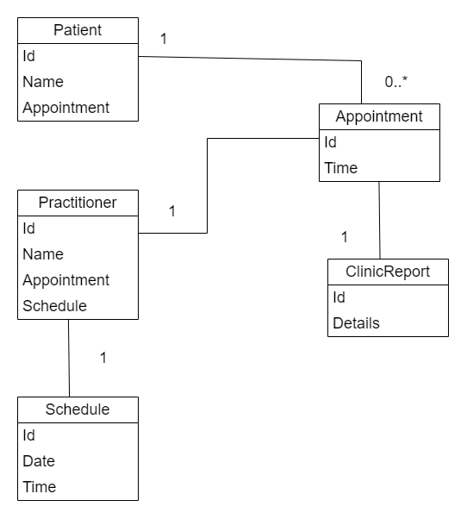

Fig: Updated UML class diagram

